**IS211**

**Assignment (1)**

**Instructor: Ms. Athoug AlSoughayer**

**Name: Randa Alhammad**

**ID: #213410112**

**Section: #848**

**Site goal:**

The website is particularly for children between 8-12 years old. The website could help children to be educated about the main planets existing in the solar system. I was inspired by the nephew, when I saw him watching an animated show for kids which was about various interesting facts about the solar system and its family. The main goal for my website is to simplify the idea of planets and make them easy for children to grasp and understand in an entertaining way.

**HTML Elements:**

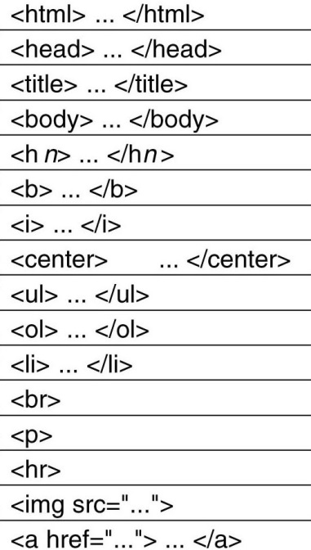

**Sitemap:**